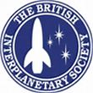

New Directions in Space Colonisation
A workshop hosted by the School of Humanities, University of Hertfordshire. Organised as part of the British Interplanetary Society’s ongoing Space Colonies Project
University of Hertfordshire
Saturday 11th April
De Havilland Campus, Room R010, 10:00-16:00.

The purpose of this event is to explore the viability of space colonisation in the light of emerging technologies, the existing legal framework and new ethical debates.

Programme

10:00 -10:15
Introduction to the day: ‘The Space Colonies Project’
Jerry Stone (President, Mars Society UK)
10:15 - 11:00
‘The Extraction and Processing of Lunar Resources’
Mike Leggett (BIS)

11:00 - 11:15 BREAK

11:15 - 12:00
‘Legal Issues of Space Settlement’
Adam Manning (BIS)

12:00 – 13:30: LUNCH

13:30 – 14:15
‘Anhydrous Glass Radiation Shields for Spacecraft and Orbital Habitats’
Richard J Soilleux (BIS)

14:15 – 15:00
'Are we there yet? The Ethics of Justifying O’Neil Colonies’
Tony Milligan (University of Hertfordshire)

15:00 – 15:15 BREAK

15:15 – 16:00
Final Session by video-link: ‘Space Colonies and their Critics'
Gonzalo Munevar (Lawrence Tech University, Michigan)

Directions: There is more than one university campus in Hatfield. Go to the De Havilland Campus. (This is near to The Galleria/Comet Way, which is well signposted throughout Hatfield.) Regular campus parking restrictions do not apply on Saturdays. Head to the main building. Directions will be posted from there to the venue, Room R010. The room is on the ground floor for ease of access. If in doubt, phone Tony on 07966 478287. This number will be active on the day.

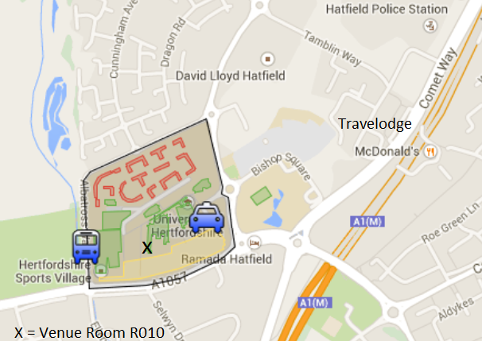

For Further Information: contact Tony Milligan, t.milligan@herts.ac.uk

